# What is Microservices ?

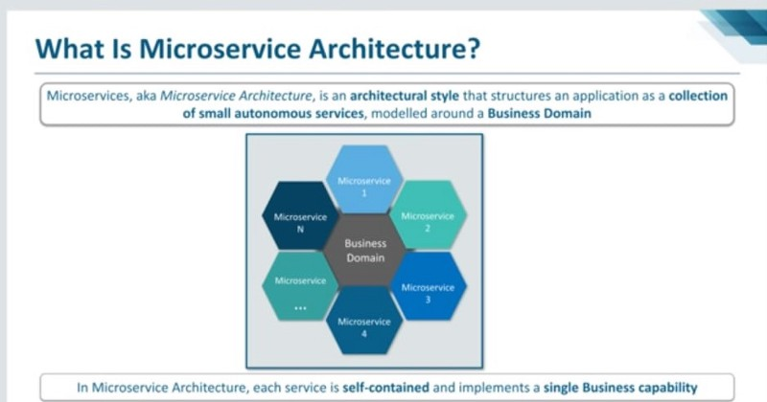

Microservices is a hot topic in software development circles these days. And for some very good reasons.

Put simply, the traditional way of building enterprise applications — using a [monolithic approach](https://en.wikipedia.org/wiki/Monolithic_application) — has become problematic as applications get larger and more complex. So developers are turning to a microservices software development architecture, in which applications are structured as collections of loosely coupled services. This makes them easier to build, and — more importantly — much easier to expand and scale.

Let’s take a closer look at how a microservices approach differs from a monolithic one, and examine their relative strengths and weaknesses. Before moving further first we understand the Monolithic architecture in detail, in order to understand the microservices better and later we will also differentiate among them so that you are about to be a pro in the topic.

# What is Monolithic Architecture??

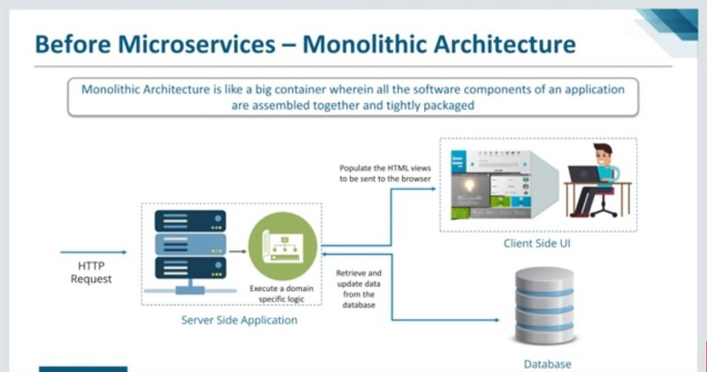

A monolithic architecture is the traditional unified model for the design of a software program. Monolithic, in this context, means composed all in one piece. Monolithic software is designed to be self-contained; components of the program are interconnected and interdependent rather than loosely coupled as is the case with modular software programs. In a tightly-coupled architecture, each component and its associated components must be present in order for code to be executed or compiled.

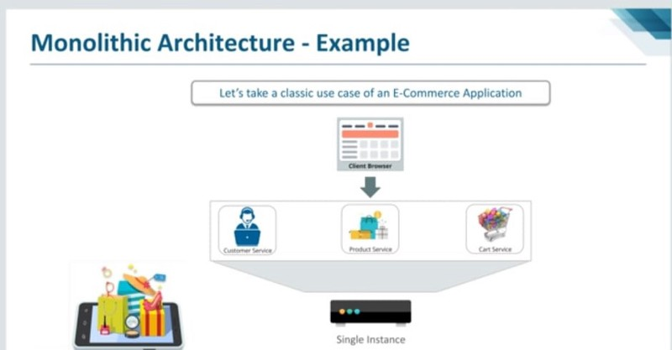

In our example of E-commerce application, let’s figure out the Monolithic Architecture is , so as u see that in basic e-commerce application, we have common options of costumer service,product service and cart service which a costumer can access through their browser, and when you launch the application it is deployed as single monolithic application. There is only one single instance, so we have costumer service,product service and cart service and when you deploy all these services, it will be basically a single monolithic application.Now what you can do is, in order to scale it you can run multiple instances of this application behind a load balancer.

# Advantages of Monolithic Architecture:

* Simple to develop.
* Simple to test. For example you can implement end-to-end testing by simply launching the application and testing the UI with Selenium.
* Simple to deploy. You just have to copy the packaged application to a server.
* Simple to scale horizontally by running multiple copies behind a load balancer.

# Challenges of Monolithic Architecture:

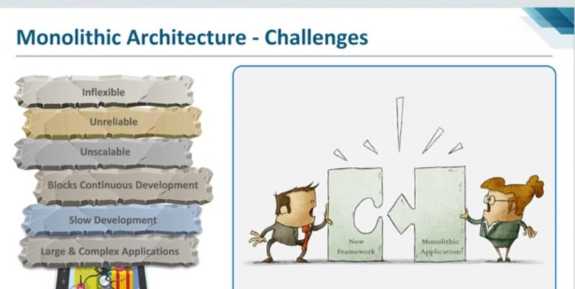

* This simple approach has a limitation in size and complexity.
* Application is too large and complex to fully understand and made changes fast and correctly.
* The size of the application can slow down the start-up time.
* You must redeploy the entire application on each update.
* Impact of a change is usually not very well understood which leads to do extensive manual testing.
* Continuous deployment is difficult.
* Monolithic applications can also be difficult to scale when different modules have conflicting resource requirements.
* Another problem with monolithic applications is reliability. Bug in any module (e.g. memory leak) can potentially bring down the entire process. Moreover, since all instances of the application are identical, that bug will impact the availability of the entire application.
* Monolithic applications has a barrier to adopting new technologies. Since changes in frameworks or languages will affect an entire application it is extremely expensive in both time and cost.